Protractor Architecture

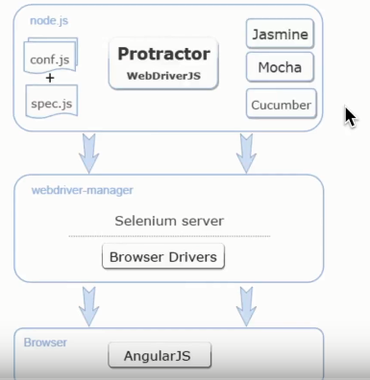

1. Create folder and then open in visual studio
2. Download and install Node.js and check version node –v
3. Open terminal and do run npm init command
4. Package.json file will be created

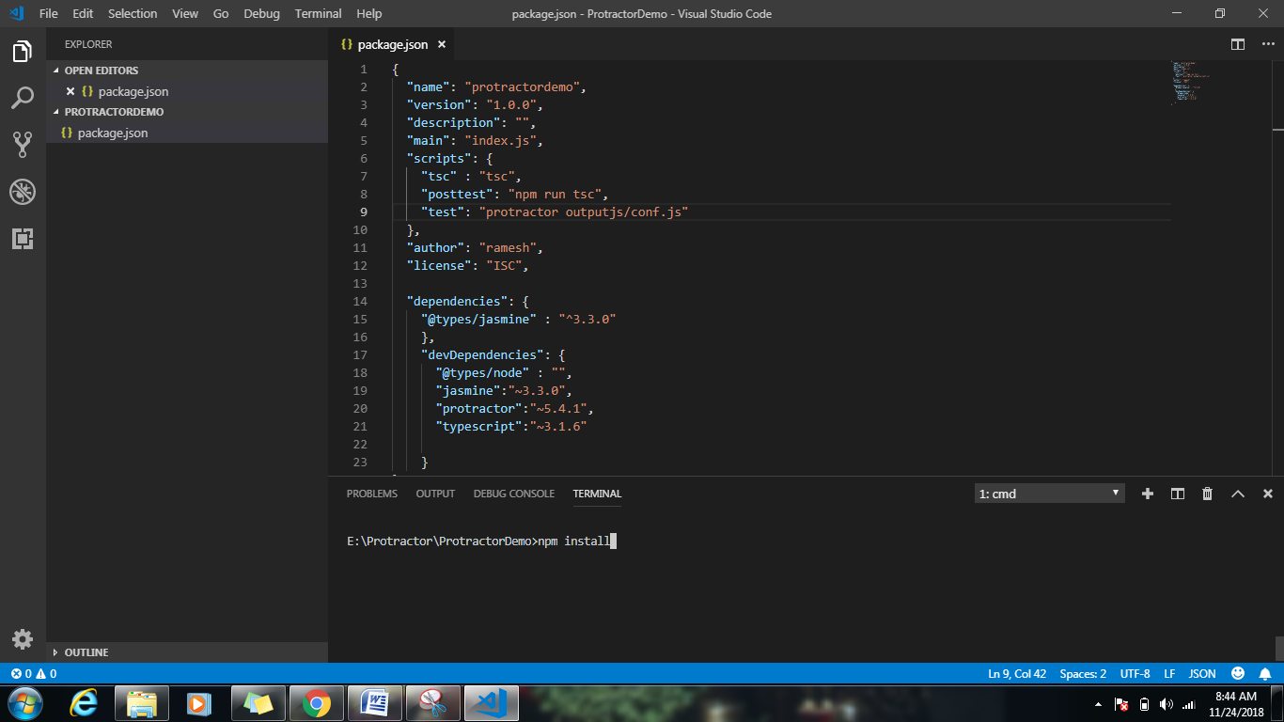

Run > npm install

Install typescript globally

Npm install –g typescript

After follow below steps

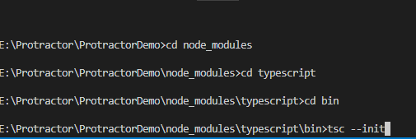

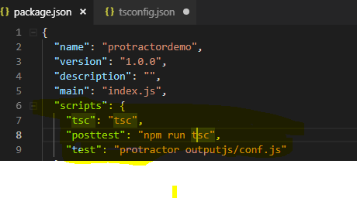

Till now performed below operations

1. Create package.json
2. Install node_modules
3. Create tsconfig.json
4. Modify tsconfig.json file

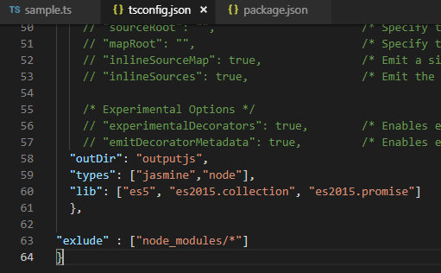

Create sample calculator.ts file then compile > tsc calculator.ts

* Node_modules/.bin/webdriver-manager update
* 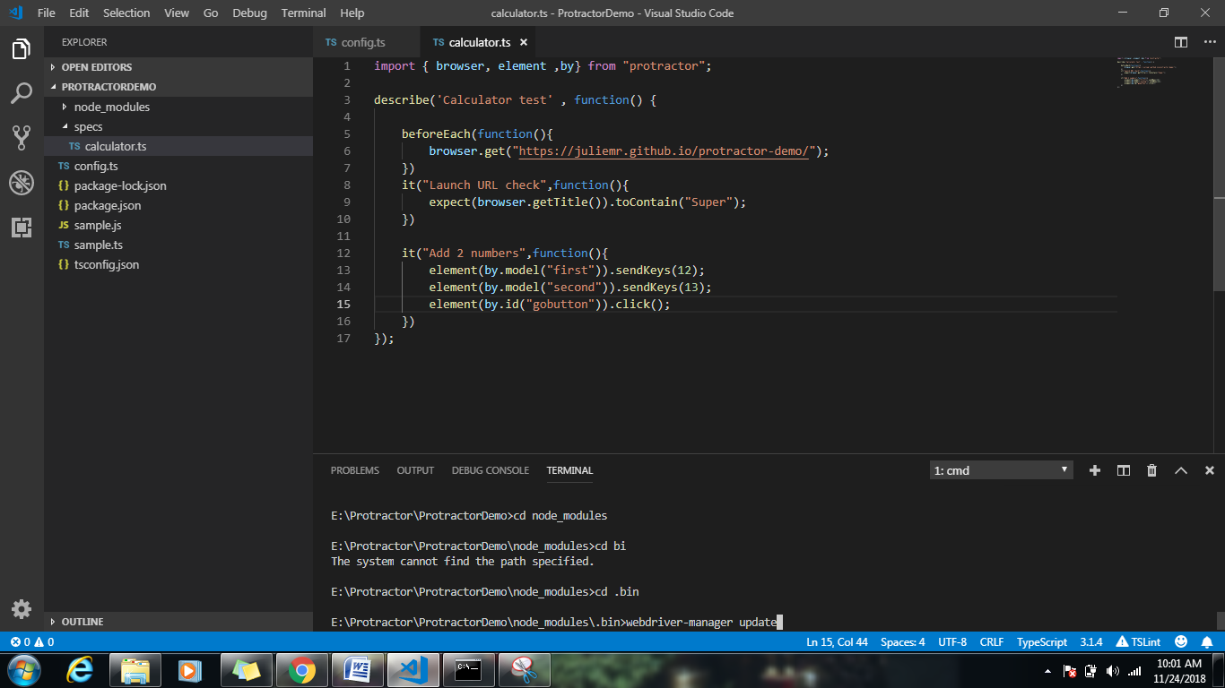

Run tests on firefox

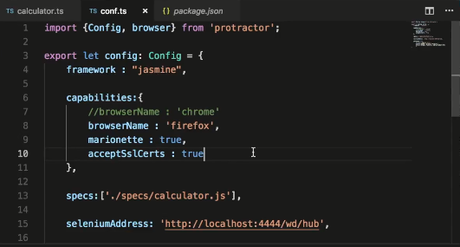

Protractor logging mechanism

Console.log(“Logging info…..”);

Using Then() function

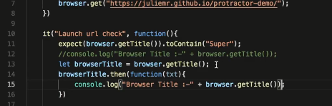

Npm install log4js

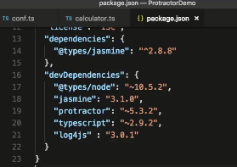

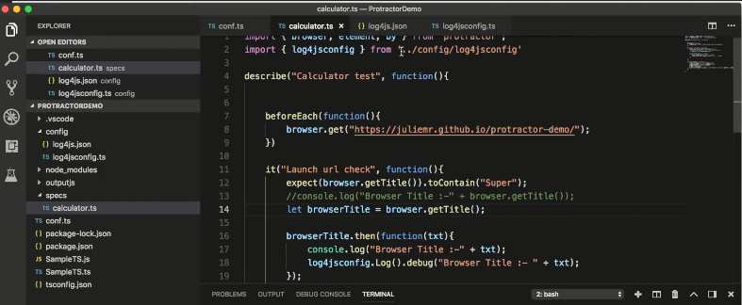

{

"appenders": {

"console" : {

"type": "console",

"category": "console"

},

"file" : {

"category": "test-file-appender",

"type": "file",

"filename": "log_file.log",

"maxLogSize": 10240,

"backups": 3,

"pattern": "%d{dd/MM hh:mm} %-5p %m"

}

},

"categories": {

"default" :{"appenders": ["console", "file"], "level": "DEBUG"},

"file" : {"appenders": ["file"], "level": "DEBUG"}

}

}

export class log4jsconfig{

static Log(): any {

var log4js = require('log4js');

log4js.configure('./config/log4js.json');

//var logger = log4js.getLogger(); //for both console and file

let log = log4js.getLogger("default");

return log;

}

}

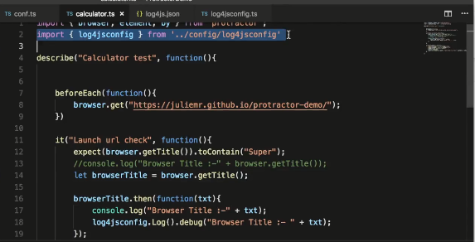

Working with popup and validate alert msg

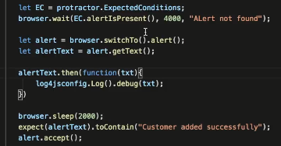

Alert reusable function

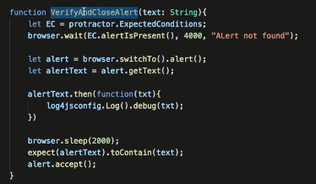

Working with drop down and select one option from drop down

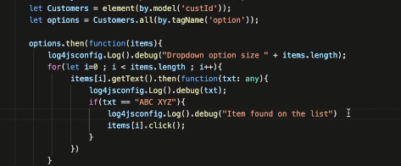



Browser.sleep(3000);

Working with tables

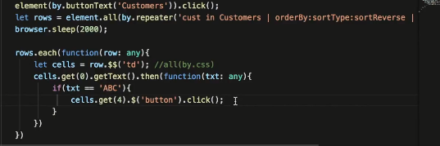

Working on Non Angular sites

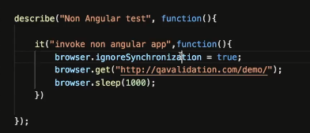

Handline Multipule windows

